Doctors of BC – Office of President Elect Debate
with Drs. Eric Cadesky and Jean-Noel Mahy
Moderator: Dr. Arun Garg

Wednesday July 12th, 2017
Seasons in the Park at Queen Elizabeth Park
Summit Room
West 33rd Avenue, Vancouver

☐ 5:30 pm – Pre-dinner Cocktails (cash bar) Members and Guests: $65.00

☐ 6:30 pm - Dinner Residents and Medical Students: $55.00

☐ 7:30to 9pm - President-elect debate (Doctors of BC)

Return forms with cheques to “Vancouver Medical Association”, c/o115-1665 W Broadway, Vancouver, BC, V6J 5A4. Alternatively, cheques will be accepted at the event.

Kindly confirm your attendance by email to vma.manager@gmail.com by Wednesday, July 5th.

Name: Click here to enter text. Amount: Choose an item.

Food allergies/restrictions: Click here to enter text.

Name: Click here to enter text. Amount: Choose an item.
Food allergies/restrictions: Click here to enter text.

*Register for full membership to the Vancouver Medical Association $25.00 ☐

TOTAL: Click here to enter text. Email Address: Click here to enter text.

PAYMENT ENCLOSED/MAILED ☐ PAYMENT AT EVENT ☐
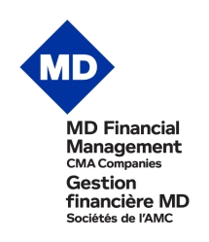

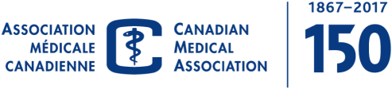
Sponsored in part by

